QUESTION 1 – Write A Program For Deleting An Element From The Beginning And From Any Position.

Ans –

#include<stdio.h>

void main()

{

int a[5];

int i,p,n;

printf("\n Enter Size Of The Array ");

scanf("%d",&n);

printf("\n \n Enter Elements ");

for(i=0;i<n;i++)

{

scanf("%d",&a[i]);

}

printf("\n \nEntered Array Is - ");

for(i=0;i<n;i++)

{

printf("%d ",a[i]);

}

printf("\n \nArray After Deleting An Element From The

Beginning - ");

for(i=1;i<n;i++)

{

printf("%d ",a[i]);

}

printf("\n \n");

printf("\n Enter The Index You Want To Delete ");

scanf("%d",&p);

for(i=p;i<n;i++)

{

a[i]=a[i+1];

n--;

}

printf("\n \nArray After Deleting A User's Choice Value - ");

for(i=0;i<n;i++)

{

printf("%d ",a[i]);

}

printf("\n \n");

}

Output –

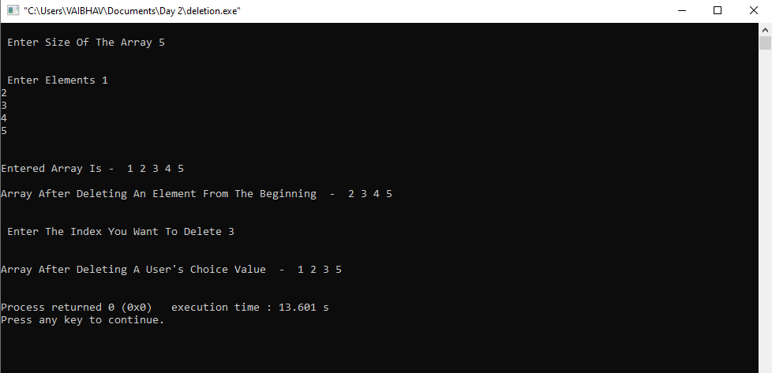

Question 2 – Write a program for printing . . the Array after rotating it 'K' times towards . . . . left, where K would be taken as User Input.

Ans –   
 #include<stdio.h>

void main()

{

int a[5];

int i,k,j,temp;

printf("\n Enter Elements - ");

for(i=0;i<5;i++)

{

scanf("%d",&a[i]);

}

printf("\n \nEnter How Many Times You Want To Rotate - ");

scanf("%d",&k);

printf("\n \nEntered Array - ");

for(i=0;i<5;i++)

{

printf("%d ",a[i]);

}

for(j=1;j<=k;j++)

{

temp=a[0];

for(i=0;i<4;i++)

{

a[i]=a[i+1];

}

a[i]=temp;

}

printf("\n \nArray After Rotating %d Times - ",k);

for(i=0;i<5;i++)

{

printf("%d ",a[i]);

}

printf("\n \n");

}

Output –

